A World Oil Map

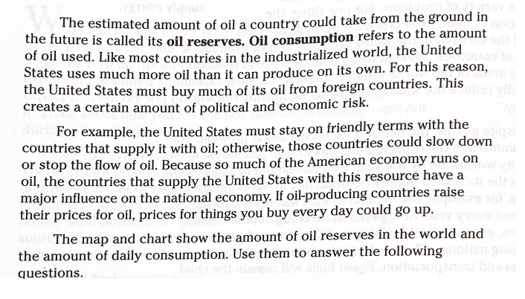

The map and chart is on the second page. Please answer the questions in complete sentences.

1. Which region of the world holds the most oil reserves? What percentage of the world's oil is in this region? **The percentage is 62% and the region that holds the most oil reserves is the middle east.**
2. Which region of the world uses most of the world's oil? What percentage of the world's oil does this region use? **North America and the percentage is 30%.**
3. Which region of the world has the least oil reserves? How do you think this affects the region's economy? **Western Europe has the least amount of oil reserves; the percentage is 1.5%. I think it doesn’t have that much oil reserves because it doesn’t have enough people.**
4. Besides the Middle East, which regions of the world probably ship oil to other nations? Why do you think this may be so? **I think it is Eastern Europe and the former USSR because it has a lot of oil and other countries don't, so it would be the perfect country to ship oil to other nations.**
5. Which region has the world's second-largest oil consumption? **The Asia Pacific region has 29% of the world's oil consumption.**

